Задание 1

1)

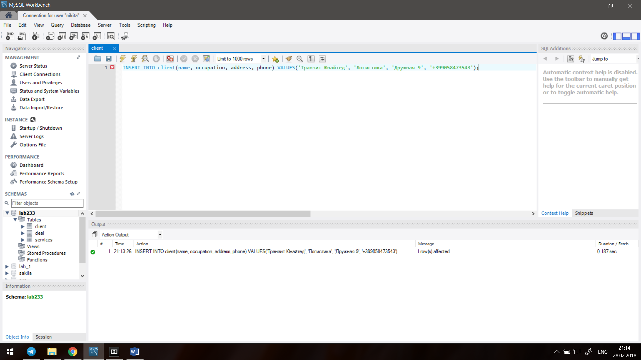

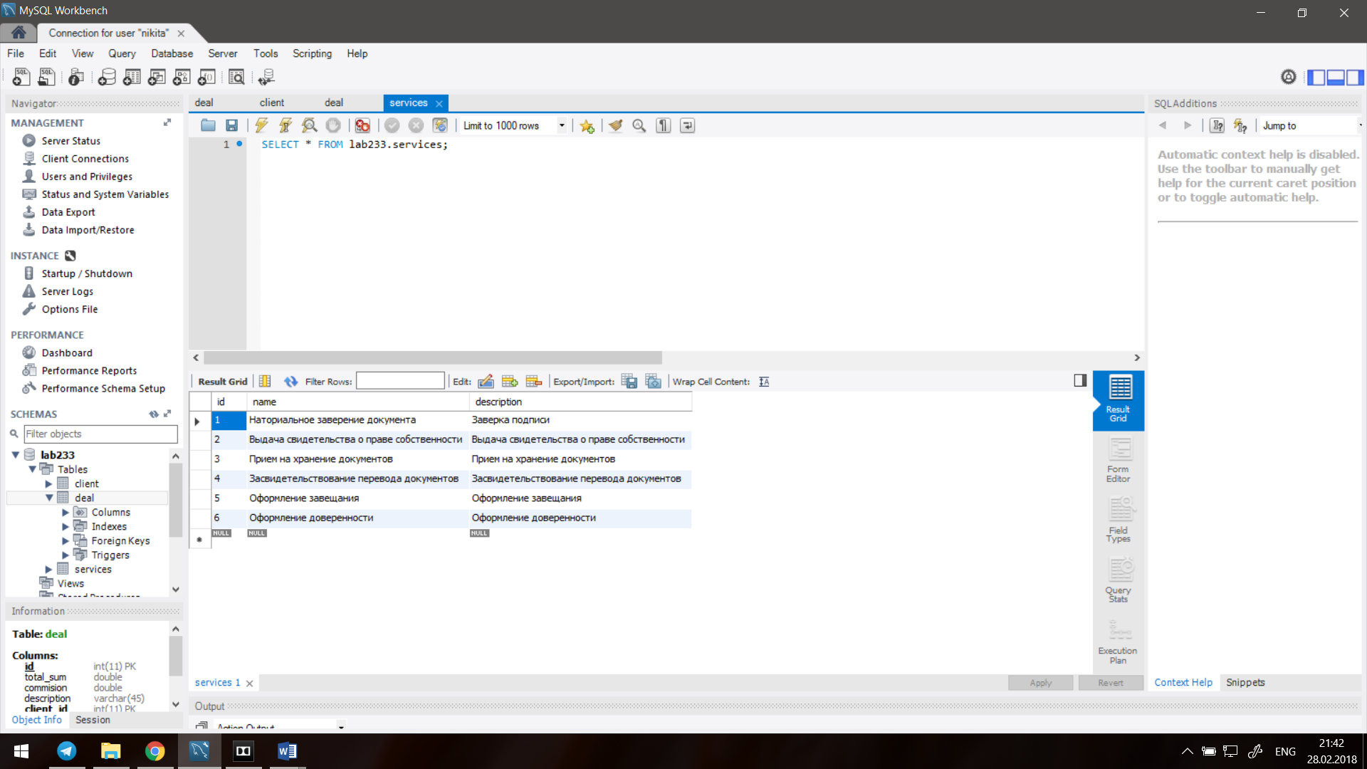

2) SET SQL_SAFE_UPDATES = 0;

UPDATE client SET address='none';

UPDATE deal SET total_sum=500, commision=40 WHERE id=1;

UPDATE services SET name= 'Заверение документа', description='Заверка', WHERE id=1 OR id=2;

3) REPLACE INTO deal SET id = 1, total_sum = 10;

REPLACE INTO deal SET id = 10, total_sum = 10, commission=10, description = ‘asdas’, client_id=2, services_id =1;

4)

